**Assignment**

**-2**

|  |  |
| --- | --- |
| Assignment Date | 8 November 2022 |
| Student Name | Anju M |
| Student Roll Number | 210819104010 |
| Maximum Marks | 2 Marks |

**Question-1:**

1. Create a Flask App
2. Add the Home page, About Page
3. Add the Bootstrap
4. Add the Sign in page and App the Signup Page

|  |
| --- |
| from flask import  Flask,render_template,request,url_for,redirect,flash from markupsafe import escapeapp=Flask(name__)  @app.route("/")def index():  return render_template("home.html")  @app.route("/home.html") def hello():  return render_template("home.html")  @app.route("/about.html") def profile():  return render_template("about.html")  @app.route("/signup.html") def signup():  return render_template("signup.html")  @app.route("/signin.html") def signin(): |

**Solution:app.py:**

|  |
| --- |
| return render_template("signin.html")  @app.errorhandler(404)def page_not_found(error):  return render_template('page_not_found.html'),404 |

**Templates:**

**Home page**

|  |
| --- |
| {% extends 'base.html'%}  {% block head %}  <title>home page</title>  {% endblock %}  {% block body %}  <main class="px-3">  <h1>Cover your page.</h1>  <p class="lead">hi you can signin here </p>  <p class="lead">  <a href="signup.html" class="btn btn-success">Signup</a>  </p>  </main>  {% endblock %} |

**Base page**

|  |
| --- |
| <!DOCTYPE html>  <html lang="en">  <head>  <meta charset="utf-8">  <meta name="viewport" content="width=device-width, initial-  scale=1"><link href=["https://cdn.jsdelivr.net/npm/bootstrap@5.0.2/dist/css/bootstrap.min.](https://cdn.jsdelivr.net/npm/bootstrap%405.0.2/dist/css/bootstrap.min)css" rel="stylesheet" integrity="sha384-  EVSTQN3/azprG1Anm3QDgpJLIm9Nao0Yz1ztcQTwFspd3yD65VohhpuuCOmLASjC" crossorigin="anonymous">  <script  src=["https://cdn.jsdelivr.net/npm/bootstrap@5.0.2/dist/js/bootstrap.bundle](https://cdn.jsdelivr.net/npm/bootstrap%405.0.2/dist/js/bootstrap.bundle).min.js" integrity="sha384-  MrcW6ZMFYlzcLA8Nl+NtUVF0sA7MsXsP1UyJoMp4YLEuNSfAP+JcXn/tWtIaxVXM" crossorigin="anonymous"></script> |

|  |
| --- |
| <!-- <link rel="stylesheet" href="{{url_for('static', filename='css/style.css')}}"> -->{% block head%}{% endblock %}  </head><body>  <nav class="navbar navbar-expand-lg navbar-light bg-light">  <div class="container-fluid">  <a class="navbar-brand" href="#">Navbar</a>  <button class="navbar-toggler" type="button" data-bs-  toggle="collapse" data-bs-target="#navbarSupportedContent" aria- controls="navbarSupportedContent" aria-expanded="false" aria-label="Toggle navigation">  <span class="navbar-toggler-icon"></span>  </button>  <div class="collapse navbar-collapse"  id="navbarSupportedContent">  <ul class="navbar-nav me-auto mb-2 mb-lg-0">  <li class="nav-item">  <a class="nav-link active" aria-current="page"  href="home.html">Home</a>  </li>  <li class="nav-item">  <a class="nav-link" href="signin.html">signin</a></li>  <li class="nav-item">  <a class="nav-link" href="signup.html">signup</a></li>  <li class="nav-item">  <a class="nav-link" href="about.html">about</a></li>  <li class="nav-item dropdown">  <a class="nav-link dropdown-toggle" href="#"  id="navbarDropdown" role="button" data-bs-toggle="dropdown" aria- expanded="false">  Dropdown  </a>  <ul class="dropdown-menu" aria-  labelledby="navbarDropdown">  <li><a class="dropdown-item" href="#">Action</a></li><li><a class="dropdown-item" href="#">Another  action</a></li>  <li><hr class="dropdown-divider"></li>  <li><a class="dropdown-item" href="#">Something else  here</a></li> |
| </ul></li>  </ul>  <form class="d-flex">  <input class="form-control me-2" type="search"  placeholder="Search" aria-label="Search">  <button class="btn btn-outline-success"  type="submit">Search</button>  </form>  </div>  </div>  </nav>  <div class="container mt-5">  {% block body %} {% endblock %}</div>  </body>  </html> |

**About page**

|  |
| --- |
| {% extends 'base.html'%}  {% block head %}  <title>about page</title>  {% endblock %}  {% block body %}  <main class="px-3">  <h1>this the about page.</h1><p>you will get it soon!!</p><p class="lead">  <a href="#" class="btn btn-lg btn-secondary fw-bold border-white bg- white">Learn more</a>  </p>  </main>  {% endblock %} |

**Signin page**

{% extends 'base.html'%}

{% block head %}

|  |
| --- |
| <title>signin page</title>  {% endblock %}  {% block body %}  <h2>SIGNIN Forms</h2>  <form action="action_page.php" method="post">  <div class="container">  <label for="uname"><b>Username</b></label>  <input class ="form-control" type="text" placeholder="Enter Username" name="uname" required>  <label for="psw"><b>Password</b></label>  <input class ="form-control"type="password" placeholder="Enter Password" name="psw" required>  <button style="margin-top: 2ex;margin-left:50%"class="btn btn- success" type="submit">Login</button>  </div>  <div class="container" style="background-color:#f1f1f1;">  <span>Forgot <a href="#">password?</a></span></div></form>  {% endblock %} |

**Signup page**

|  |
| --- |
| {% extends 'base.html'%}  {% block head %}  <title>signup page</title>  {% endblock %}  {% block body %}  <h2>SIGNUp Forms</h2>  <form action="/action_page.php">  <label for="fname">First name:</label><br> |
| <input type="text" id="fname" name="fname" class="form-control"><br>  <label for="lname">Last name:</label><br>  <input type="text" id="lname" name="lname" class="form-control"><br><br><input type="submit" value="Submit" class="btn btn-primary">  </form>  {% endblock %} |

**Output**

**Homepage:**

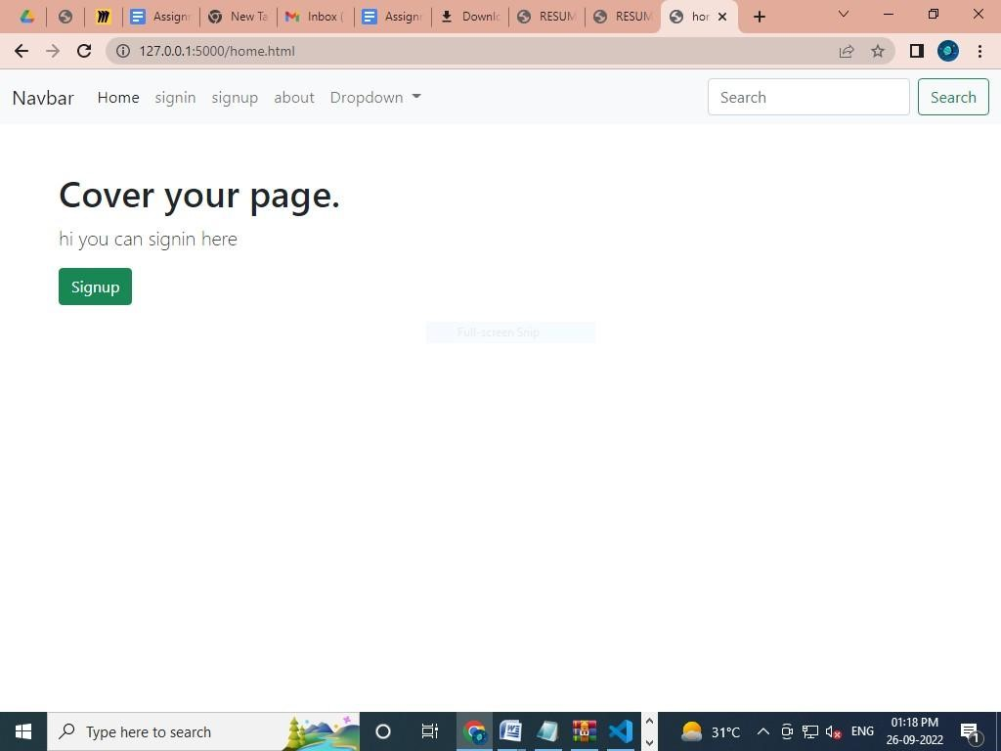

**Signin page:**

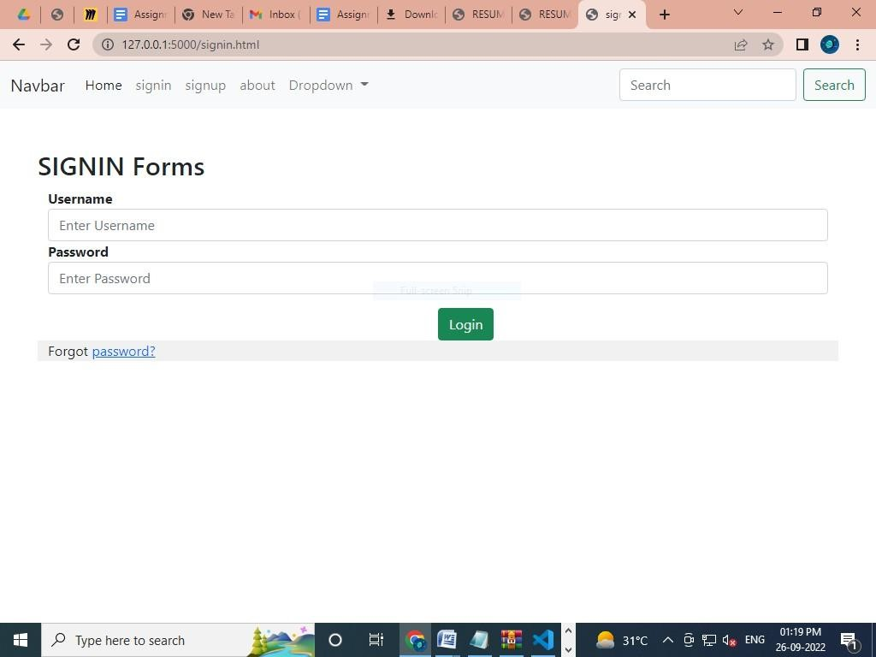**signup page:**

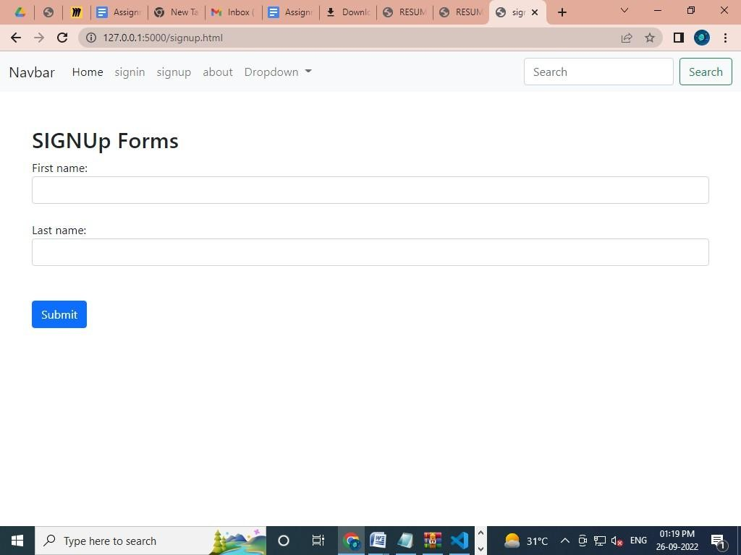

About page:

